Homework 3

1.
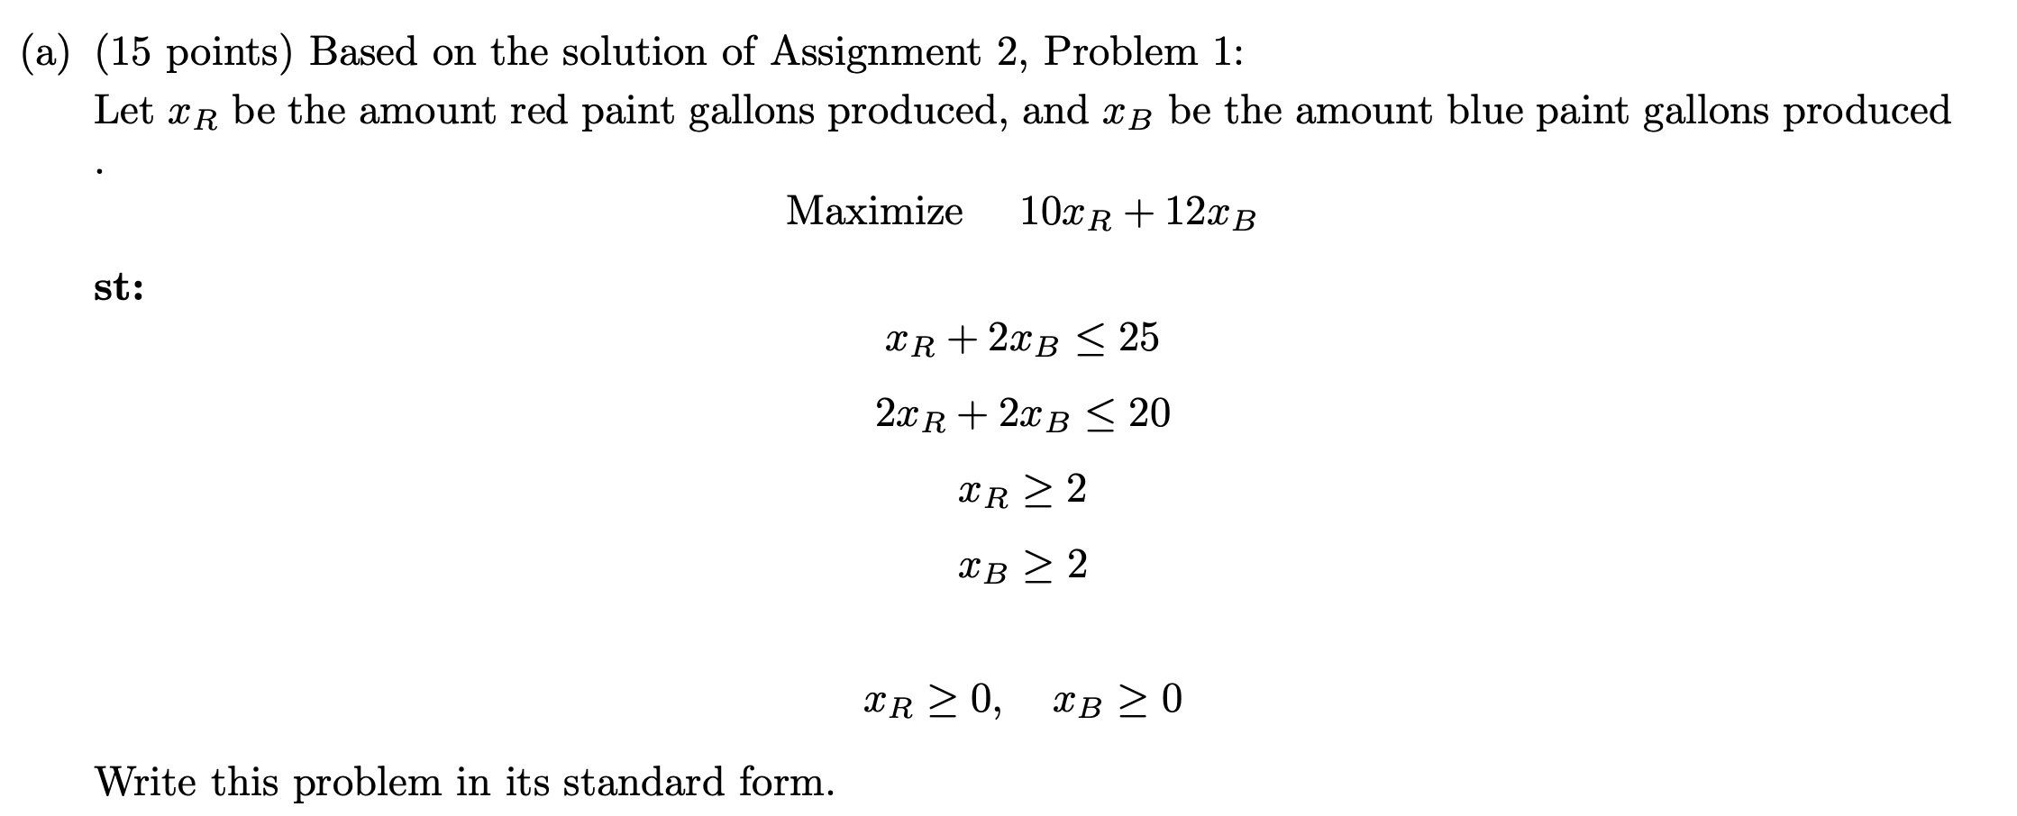

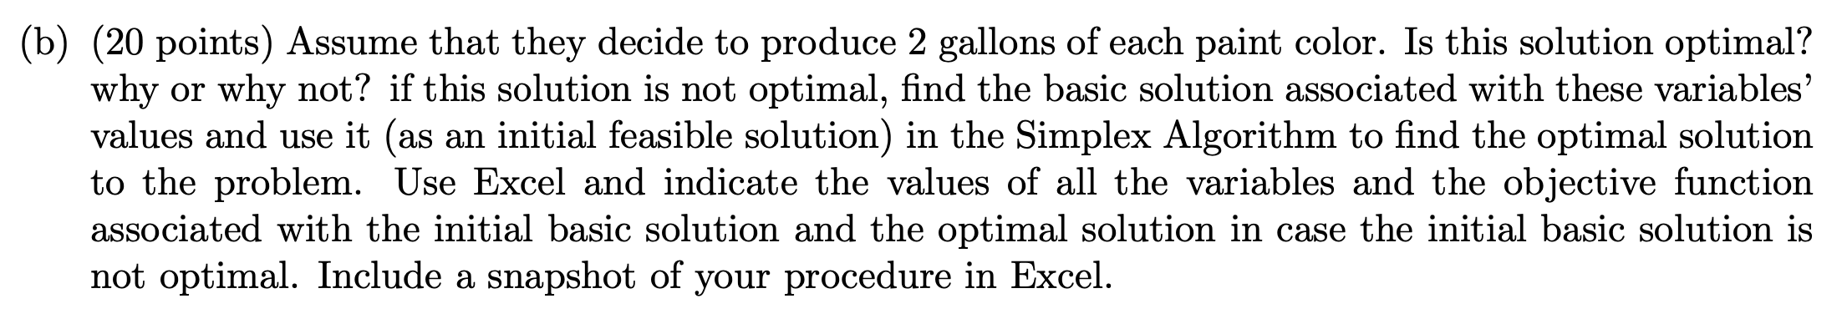

The (2,2) solution is not optimal, as seen in the graphical method (figure1), the optimal solution is not (2,2). It can be seen as well in the simplex tableau formulation (figure 2) because we are trying to maximize the objective function and we have negative values in the Z row, this means we have not reached the optimal point. In fact, in the last iteration of the simplex tableau we can observe that the optimal values are 2 for red paint and 8 gallons for blue paint.
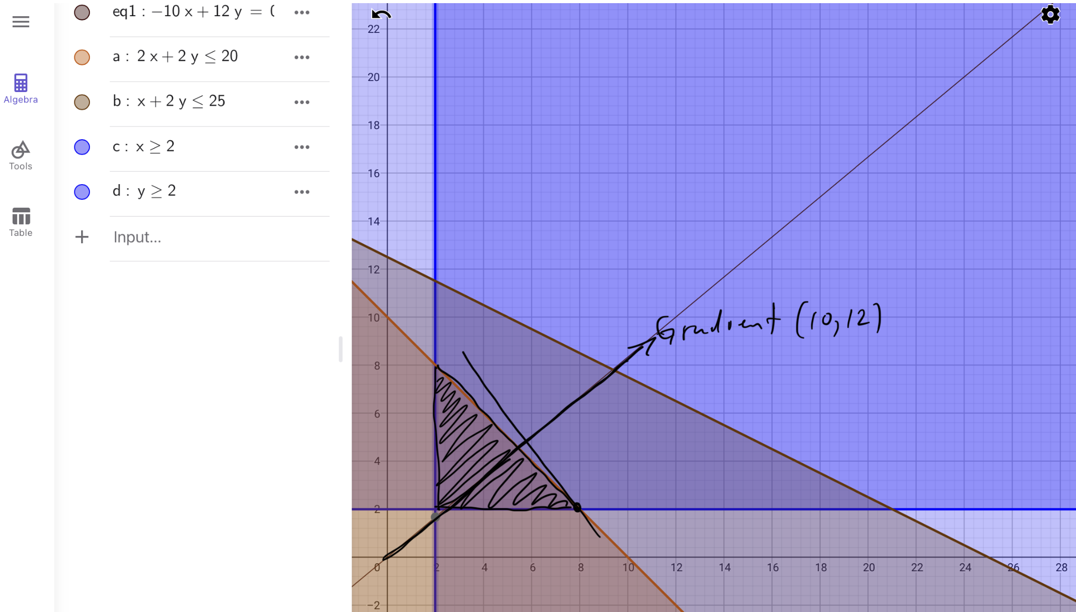
Figure 1. Model 1 graphical solution using geogebra

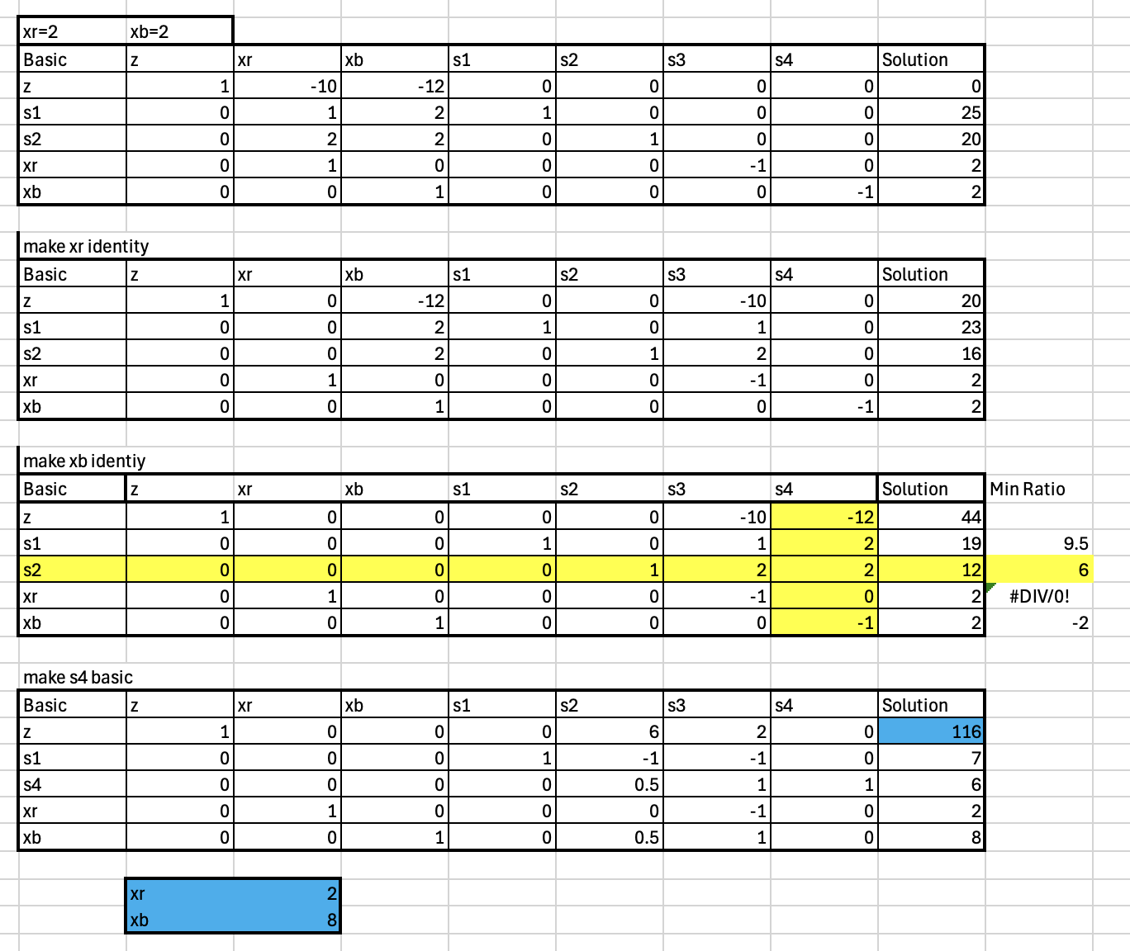
Figure 2. Model 1 simplex formulation and solution

In figure 2 we see the optimal values for xr and xb in blue, the value for the objective function (z) is also in blue.

2.
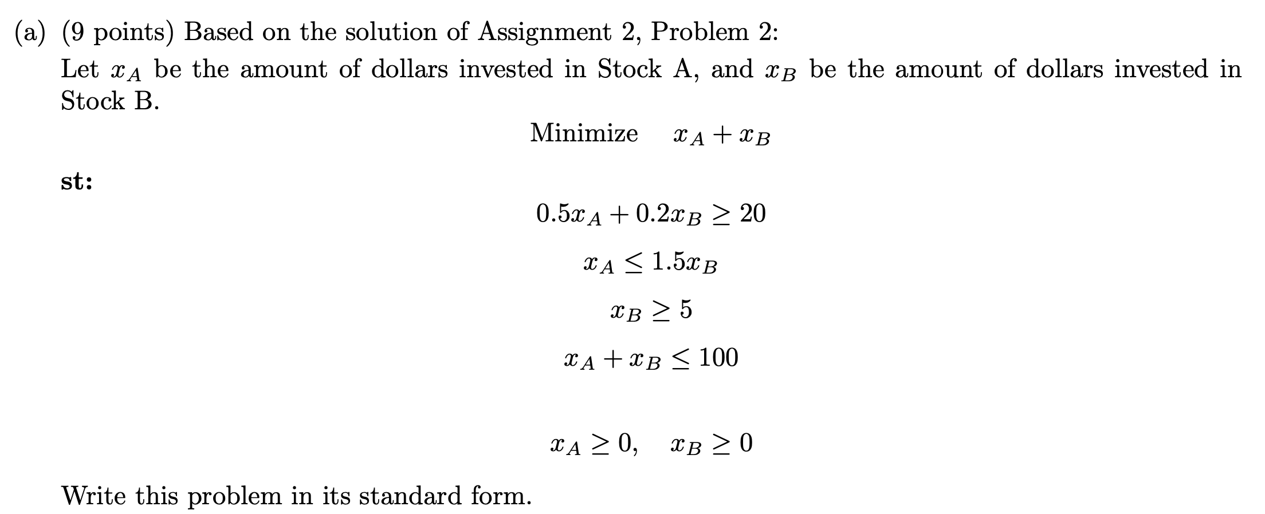

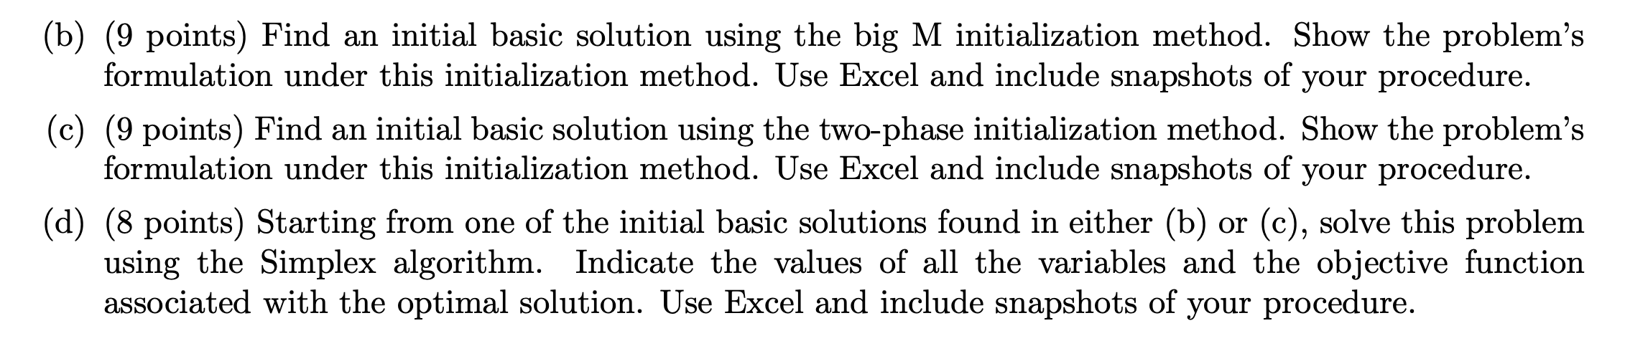

b.

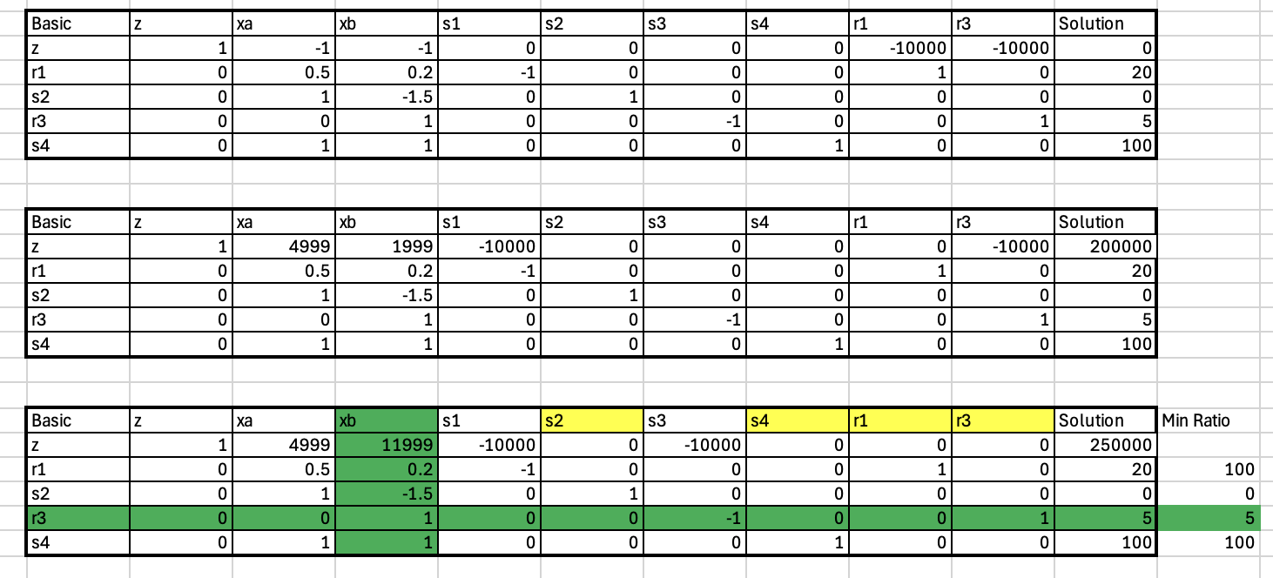
Figure 3. Model 2 simplex tableau formulation and solution using the big M method.
The initial basis for the big M methos is shown in figure 3 highlighted in yellow (r1,r3,s2,s4)

c.

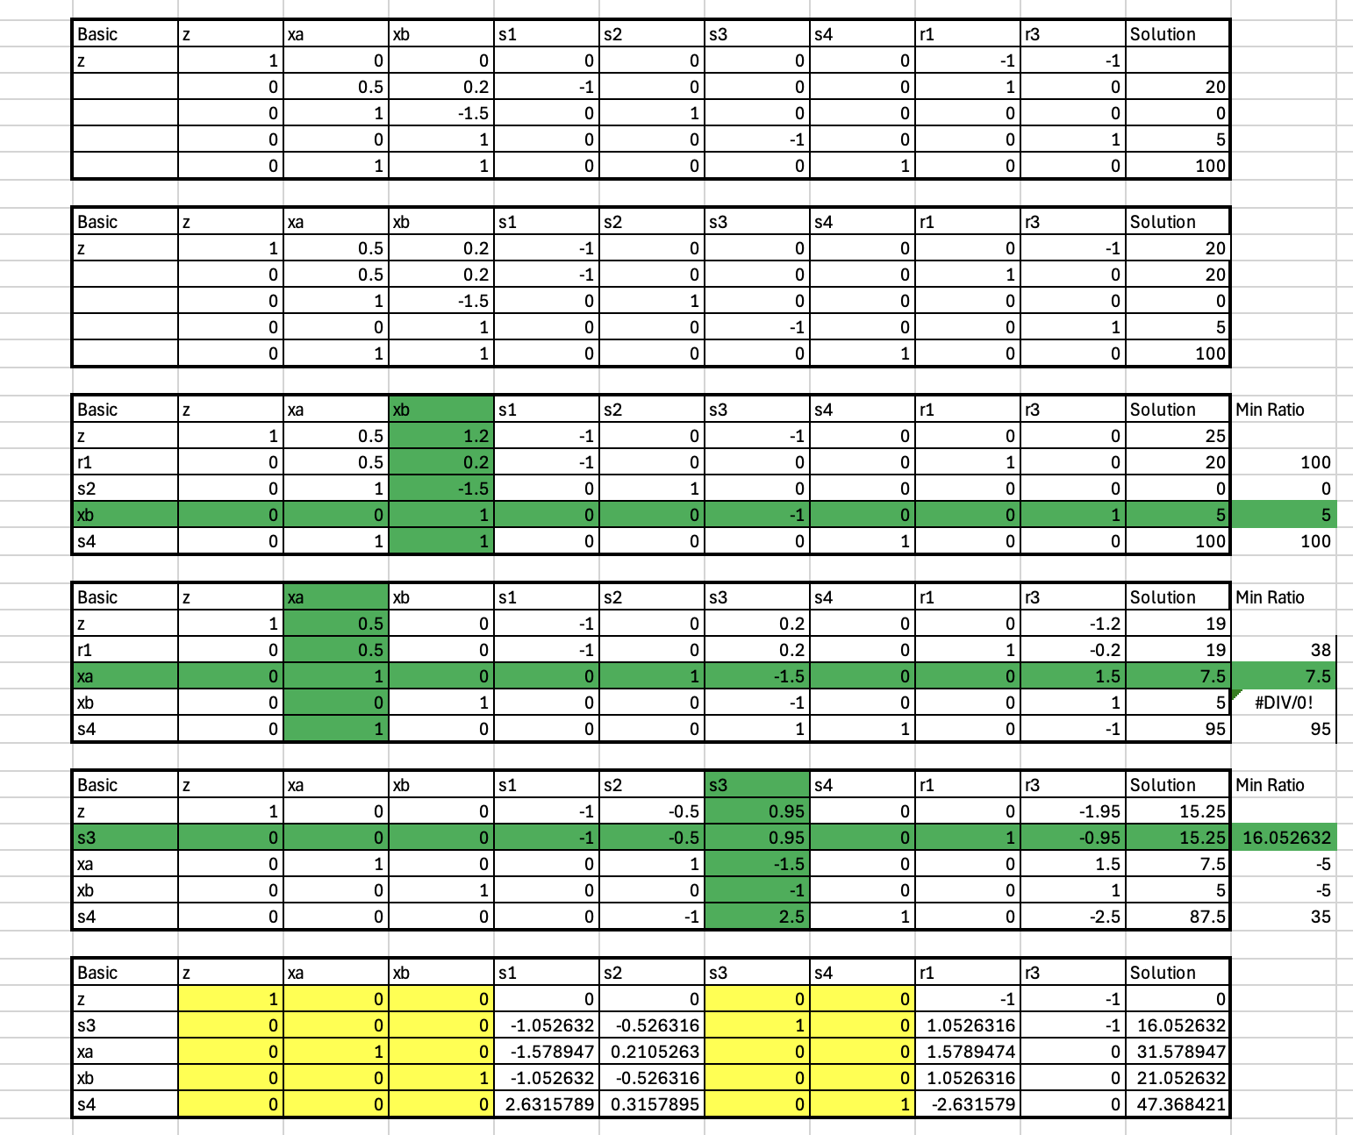
Figure 4. Two phase model 2 formulation and base solution
The initial basis using the two phase method is shown in figure 4 highlighted in yellow (xa,xb,s3,s4)

d.

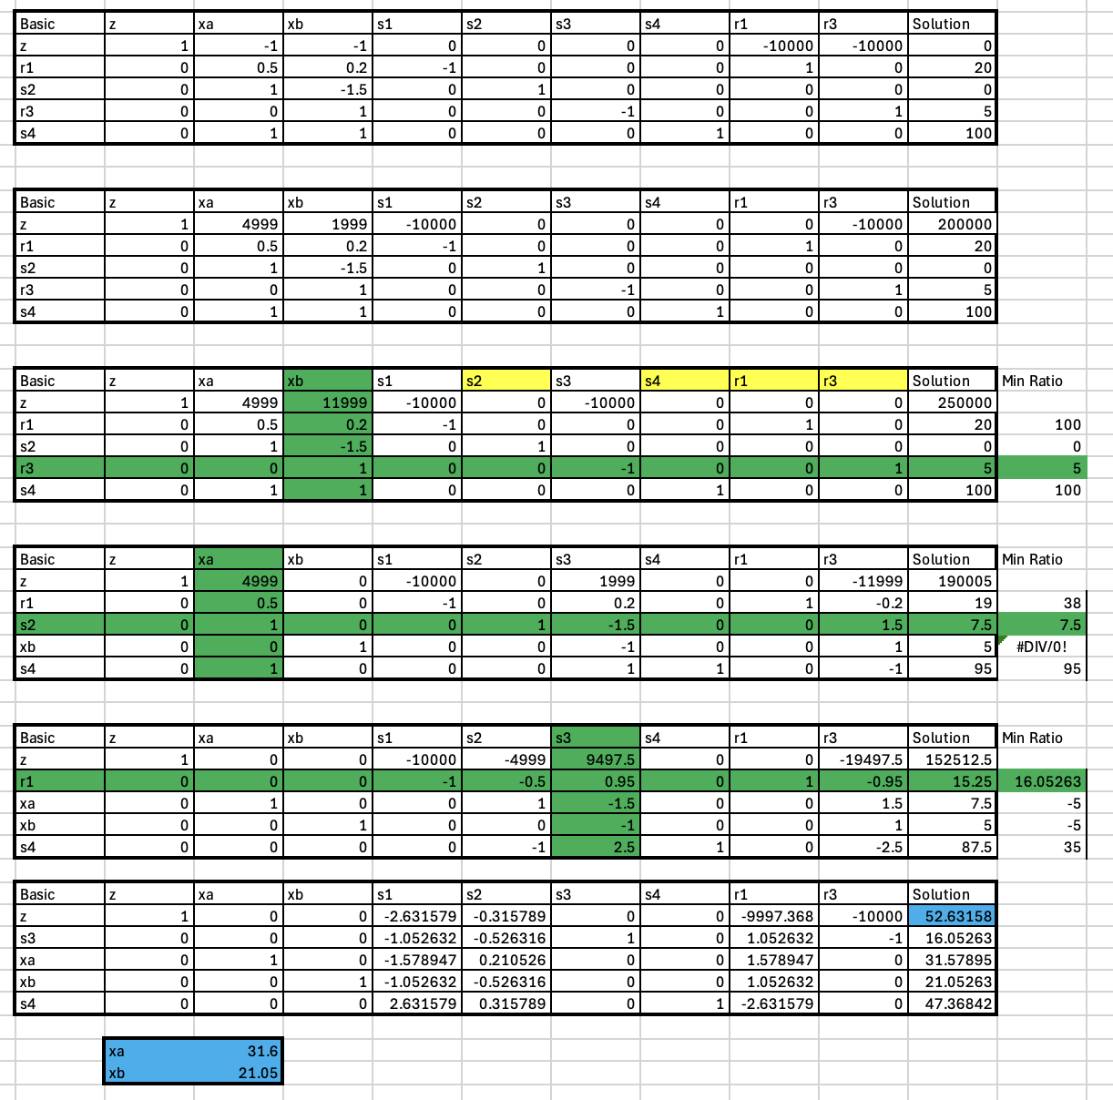
Figure 5. Model 2 solution using the big M method.

In figure 5 we see the optimal values for xa and xb in blue, the value for the objective function (z) is also in blue.

3.
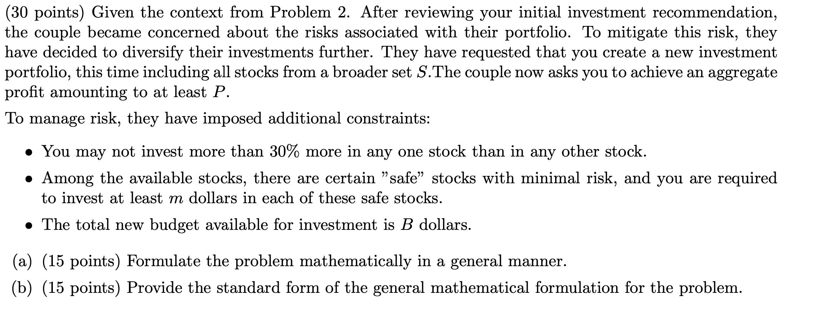
a.

b.

